**Be Courageous with your School Social Worker #TeamIsibindi**

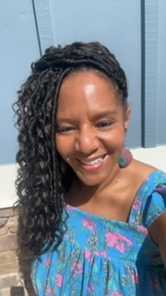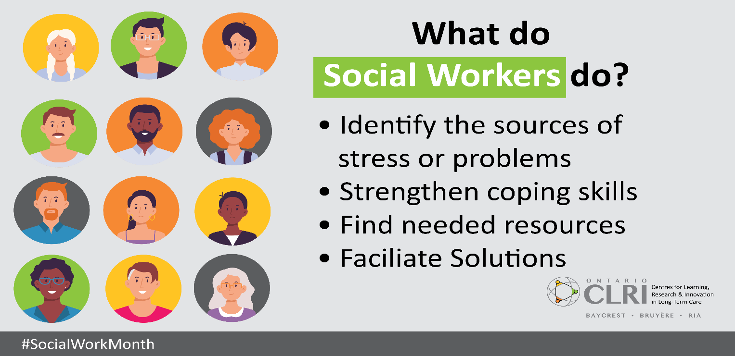

My name is ***Dr. Lydia Barnwell-Dunn*** and I am your School Social Worker for the 2024-2025 academic year.

**A Little About Me:** I have worked collectively in the fields of education and social work for approximately 30 years. This is my eighth year as a school social worker in Richmond County Public Schools and I am eager to serve the consumers of this county. Prior to becoming a school social worker, I taught high school English and Special Education for 12 years at Burke County High School in Waynesboro, Georgia.

**Assigned Schools**

Lamar Milledge Elementary School (Home School)

Meadowbrook Elementary School

Richmond County Technical and Magnet School

**Examples of Services Provided to Students, Families, Faculty and Staff**

* Academic Support Services
* Social, Emotional and Behavioral Support
* School Supplies
* Clothing Assistance
* Homeless Assistance and Advocacy
* Child care assistance referrals
* Assist with accessing medical services (ie., dental, medical, eye)
* Early education intervention
* Utility and/or Rental Assistance Referral
* Crisis/Mental health assistance
* Relationship Issues/Domestic Violence
* School Issues for Child (behavioral, academic, attendance, small groups)
* [www.csraeoa.org](http://www.csraeoa.org) – Click here to access multiple resources listed above including food options.

I look forward to working collaboratively with each one of you and providing exceptional service to the students and families of Richmond County Public Schools.

* **For School Personnel: How to submit a School Social Work Concern**
* **Log into Infinite Campus, SWARM, Concern, Create New Concern**
* **I can be reached by email at** [**dunnly@richmond.k12.ga.us**](mailto:dunnly@richmond.k12.ga.us)
* **Parents/Guardians -Notify your child’s teacher or contact the front office of your child’s school for needed services.**